**BISHOP’S CASTLE TOWN COUNCIL BRIEFING PAPER ON   
RIVER POLLUTION MONITORING ON THE RIVER KEMP**

**Why might the Town Council take an interest in river monitoring?**

* As we know, the water quality in the Clun is a critical delaying factor in any further development in the Town.
* Also, Severn Trent’s plans for diverting sewage has created a lot of interest and outrage among local citizens about river water quality.

For these reasons it should be useful for the Town Council to stay well-informed and up-to-date.

* In addition, any pollutants and toxins that are dumped on our farmlands, countryside, roads, gullies and gardens will all end up eventually in our rivers through natural runoff collected by rainwater. The recent “mystery oil leakage” is a good example.

As you can see from the local runoff Catchment map below, our local streams and rivers can act like a canary in a mine: an early warning signal of accidental or deliberate unhealthy spillage or chemical use. Having our waterways monitored is a way for us to passively police a wide area around the Town and Parish.

**Is the river quality already being monitored well enough by Severn Trent or the Environment Agency?**

No, we don’t think it is.   
For example, our information is that the Agency’s monitor above the sewage works outfall have been unsampled or failed to register readings during 4 months in 2023 and 2 months in 2024. And in fact it seems the downstream sensor hasn’t been sampled at all since September 2022.

Also, the Environment Agency reporting seems to mostly focus on the quantity of water rather than the quality. That may be because its main interest is in monitoring “overflow” discharge: when the quantity of storm runoff exceeds the sewage plant’s capacity and it has to release some untreated sewage into the river. Quantity monitoring tells us little or nothing about pollutants, or excessive nutrients coming off farms.

**The picture of local volunteer monitoring groups**

The only active local group so far has been the River Clun Monitoring Group, which monitors at 6 stations on the Clun River itself and 2 on the Kemp. On the latter, the highest point monitored is at Brockton. A sub-group has sampled upstream of Brockton on two occasions, most recently on 29 January, but they do not have the resources to continue to do this routinely, so had contacted the BC Climate Action Group to see if it could take on this work.

The most important location for BC is the outfall from its sewage works, which is on the farm known as ‘The Cottage’ and lies within the Bishop’s Castle Parish boundary. Also, key parameters of Phosphate, Nitrate and Sediment will need to be monitored, and to be substantially reduced if the housing development is to go ahead. Water monitoring is the only means to identify any problems - whether at the outfall or elsewhere - so that remedies can be put in place.

**The local river system and catchment area**

Attached is a graphic of the Clun catchment area, followed by a description of the Rivers Kemp and Onny.

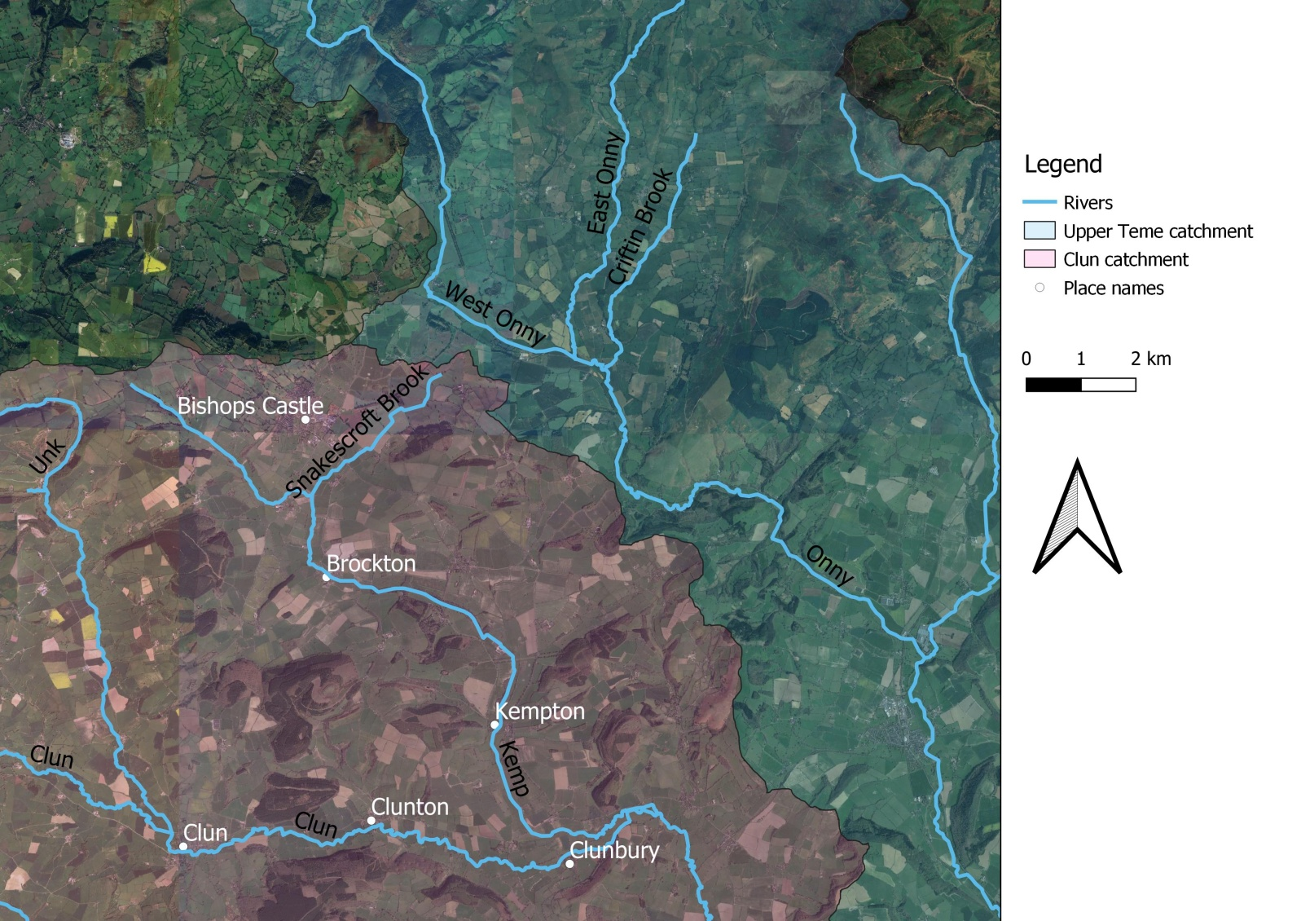

**The Kemp**  
The river Kemp is formed from two small unnamed streams that drain the area around Bishop’s Castle, the stream on the western side of the town rises near Bishops Moat and flows south-easterly in a well-defined valley. The stream to the east rises on Lydham Heath near Lea and flows in a south-westerly direction to converge with the western stream to the east of Colebatch. The River Kemp begins at the confluence of these two streams.   
From this point the river then flows south, to reach the hamlet of Brockton, where it turns in a south-easterly direction to pass through the grounds of Walcot Hall near Lydbury North. Here the river feeds the large lake known as Walcot Pool. To the south of Walcot Park, it is crossed by the Shropshire Way  and then passes through the village of Kempton, where there is a ford and footbridge. The river continues due south, until it reaches the Clun valley near Clunbury. It joins the larger river to the east of the village at Oaker near Aston on Clun.

**The Onny**  
The river Onny is a major tributary of the Teme, it has its sources in the Shropshire Hills at White Grit,   
It has two branches, the East Onny and West Onny, which converge at Eaton, to the east of Lydham. The River Onny then flows in a south-easterly direction, through Craven Arms and Onibury (a village it gives its name to) before it finally has its confluence with the River Teme just upstream of Ludlow at Bromfield. From White Grit to Bromfield, the river flows over a distance of 25 miles (40 km)  
  
BC Climate Action Group