ENERGY DIARY

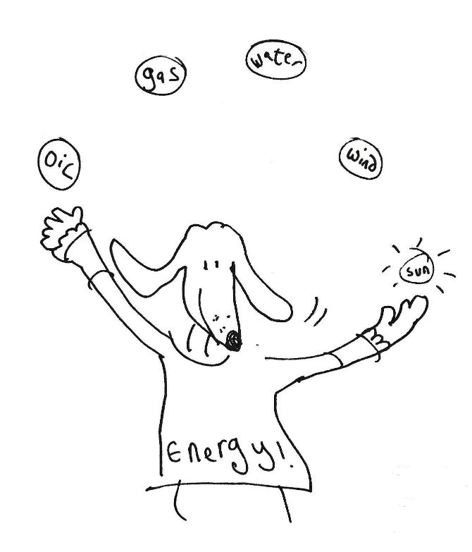

Date …………………………………………………………
Name ………………………………………………………..
Age ………………………………………………………….
Area (e.g. SY7) ……………………………………………

Dear Parent/Carer
Please could you support your child over a week to fill in this diary? The purpose of this project is to help your child:
1. Explore the many ways that energy is generated.
2. Gain an understanding, through filling in the diary of how energy is used in their home, and to help them consider how they may lower their energy use.
3. Develop an understanding that individual behaviour change can make a great difference on a national and global scale.
Embedded links are for useful further information regarding a topic, they are just a starting point for your child to explore further.
The information and emails provided will be treated confidentially and will not be passed onto any third parties without expressed permission. The answers to the riddles are at the end.
Thank you for your support.
Best regards The Lightfoot Team
E-mail: info@lightfootenterprises.org
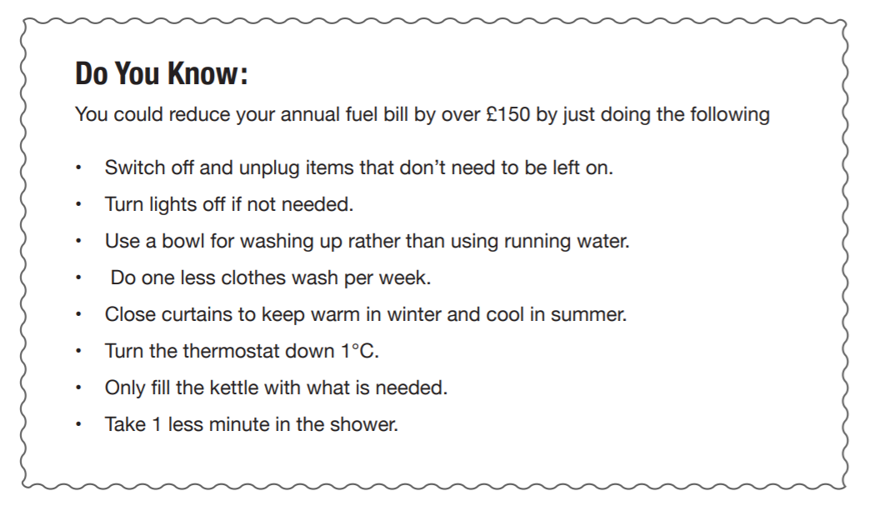
Website: http://www.lightfootenterprises.org
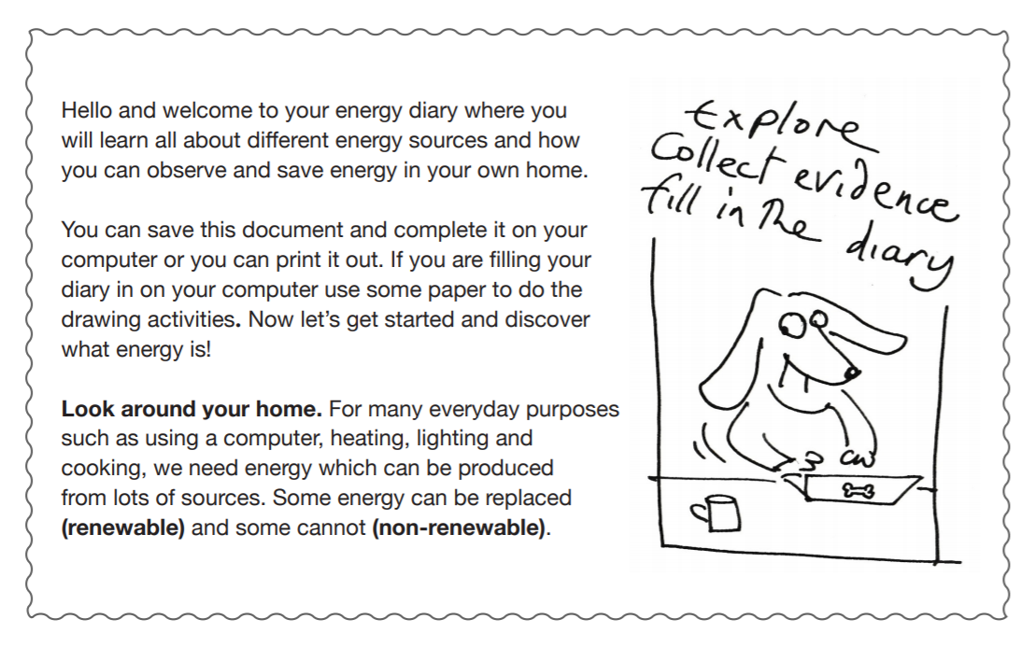
WHAT IS ENERGY?

ENERGY SOURCES
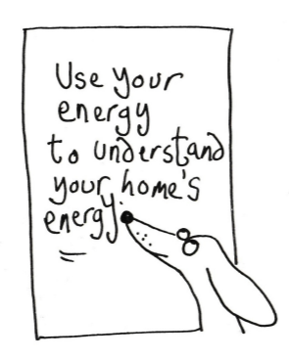
Fossil Fuels (Oil, Gas, and Coal): These are formed from plants and animals that lived between 300 million and 60 million years ago. They have to be extracted from the ground and once burned are gone for good, so they are non-renewable sources. Burning fossil fuels releases carbon dioxide (CO2), methane and other greenhouse gases into the atmosphere. To find out more about the greenhouse effect see: https://kids.britannica.com/kids/article/greenhouse-effect/403919
Nuclear: radioactive materials extracted from the ground, such as Uranium, are used to generate electricity in a nuclear reactor but this also produces radioactive waste that must be stored very carefully because it remains dangerous for thousands of years. However, the energy is produced without releasing CO2 into the atmosphere. Nuclear fuel is non-renewable.

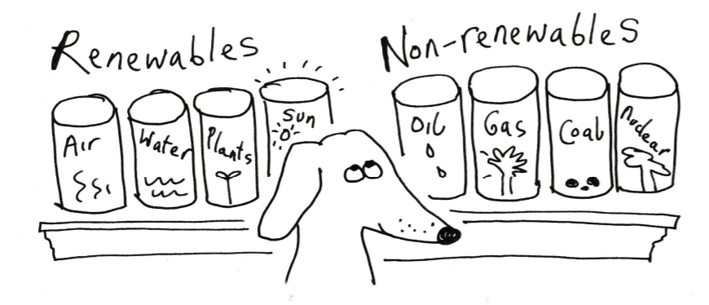
Water, Wind, and Solar are energy renewable sources that use the power of the sun, either directly as heat, or by being converted into electricity. As long as the sun shines, the wind blows and the water moves, they can provide us with energy.

Trees and Plants Trees and plants use the sun’s energy to grow, and we can use them as an energy source (Biomass fuels) by burning them. They also use CO 2 to grow and when they are burnt this CO 2 goes back to the air. Sometimes plants (and other things like cattle poo) rot and the gas (methane) is produced, often called Biogas. https://kids.kiddle.co/Biogas The methane is used as a fuel for heating homes, generating electricity or even powering buses. Find out more here! https://www.funkidslive.com/learn/

Geothermal energy comes from the Earth itself. As you drill down into the rocks, they become hotter, sometimes even molten. In Iceland, water coming into contact with hot rocks turns to steam and is used to heat houses. In Bath, this energy is being used to heat the huge cathedral buildings.

Heat pumps act like reverse fridges. The pumps extract heat from the air or the ground and use it to warm the house. Electricity powers the system, but if this is produced from 100% renewable sources, a house can have hot water and central heating without needing to burn any fuel.
Find out more here! https://www.funkidslive.com/learn/
CLIMATE CHANGE The increase of CO2 in the atmosphere is changing our climate and scientists say we must reduce the amount of CO2 by replacing fossil fuels with other energy sources and taking out some of the CO2 by planting trees. Which of the sources you have looked at are renewable? Can you think of any other renewable sources to add to your list? (clue: people power) We want loads of ideas, be as zany and creative as you like, write or draw your ideas below or on an extra piece of paper.

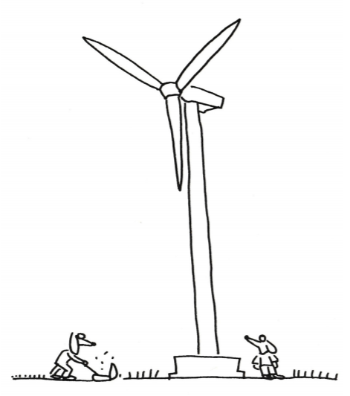

Some homes are good at making and keeping energy, some are leaky and need ways to keep the energy in.
Match the beginnings of the sentence to the sentence endings:
- Solar energy are double glazed
- Turn the light off to stop draughts from under doors
- Most energy efficient windows is renewable energy
- Use a draught excluder when you leave the room

METER WATCH
Please ask an adult to help you take a meter reading at the same time each day and work out how many units of electricity (kWh) are used in a day. For more information about which items need the most energy see: https://www.ovoenergy.com/guides/energy-guides/what-is-a-kwh-kwand-kwh-explained.html
To help you with the next section have a look at this website: https://www.funkidslive.com/learn/smart meters/what-is-a-gas-and-electricity-meterwhere-is-my-gas-or-electricity-meter/
Meter Reading | Minus | Meter Reading | Equals | Units of electricity used per day (kWh)
Day 2 | - | Day 1 | =
Day 3 | - | Day 2 | =
Day 4 | - | Day 3 | =
Day 5 | - | Day 4 | =
Day 6 | - | Day 5 | =
Day 7 | - | Day 6 | =
Total | - | Total | =

A Smart Meter is provided by your energy supplier. It measures energy, as you use it in the home, both in kWh and cost.

Do you have a Smart Meter? If yes, do you use it to see how you
YES NO can save money on bills?
YES NO

ENERGY WATCH
Please tick each day when these items are used.
Item | Day 1 | Day 2 | Day 3 | Day 4 | Day 5 | Day 6 | Day 7
Computer
Printer
TV
Satellite/BT/Sky box
DVD/Blu-Ray player
Alexa/Google/ smart device
Games Console
Kettle
Toaster
Cooker hob
Oven
Microwave
Dishwasher
Washing machine
Tumble drier
Iron
Immersion heater
Fridge
Freezer
Hair dryer
Lights
Chargers
Phone
Anything else to add?

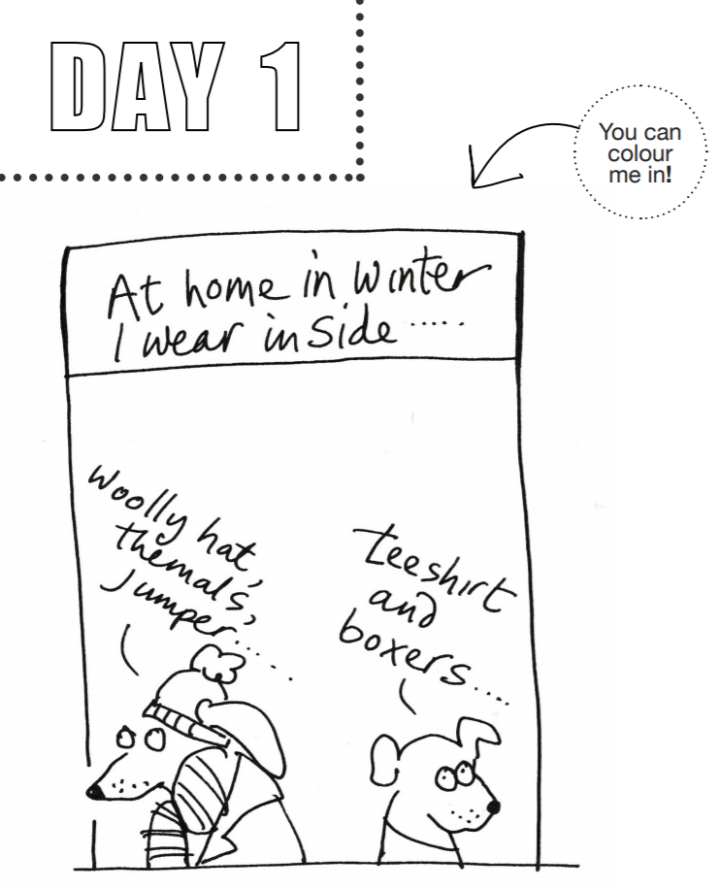

Please describe or draw the clothes that you and your family usually wear indoors in winter.

WORD SEARCH: Find the following words.
ENERGY REDUCE FUEL CARBON SOLAR PUMP
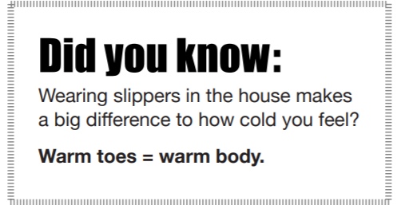
R | C | H | R | G | P
E | A | A | A | A | M
C | R | E | L | L | U
U | B | P | O | O | P
D | O | L | S | U | F
E | N | E | R | G | Y
R | F | L | E | U | F
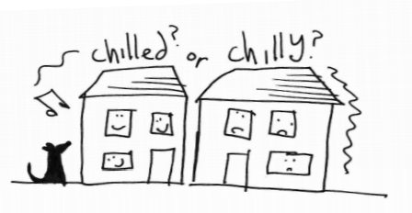
Draw a picture of the outside of your home that shows what it is made of (e.g. brick, wood etc) and what sort of house it is (e.g. bungalow) and say how many bedrooms there are.

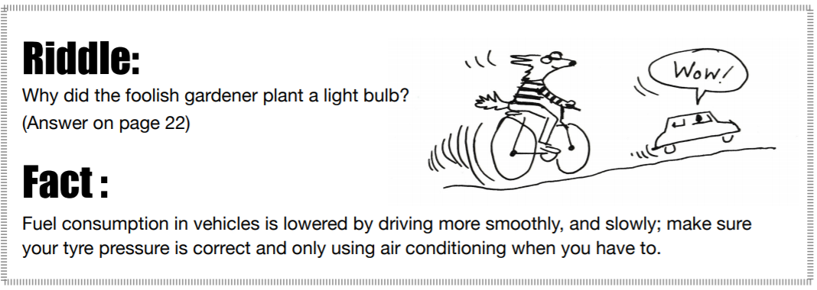

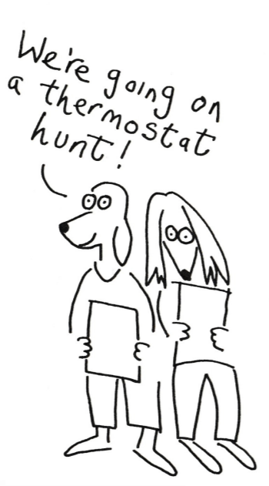
Describe where the thermostat for the central heating is fitted in your house. What temperature is it set at? (Please ask an adult to help. Do not touch the thermostat.)

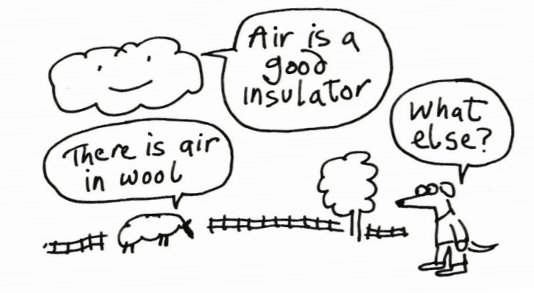

Insulation is a material that helps to keep something warm, or cold. Air is a good insulator so something like wool that traps air is excellent. Imagine going outside without a coat on in winter. https://www.funkidslive.com/learn/curious-kate/curious-facts-insulation/
Some other great ideas for insulation are....

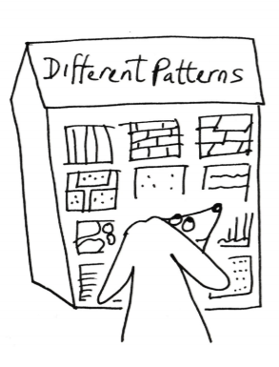
Draw small pictures of the patterns you see on the outside walls and roof of your home.
Label your picture to show the materials used.
Find out For example if they have insulation in, behind or under them. For example wool, fibre glass, shredded paper and so on. You can use an extra sheet of paper if you need to.

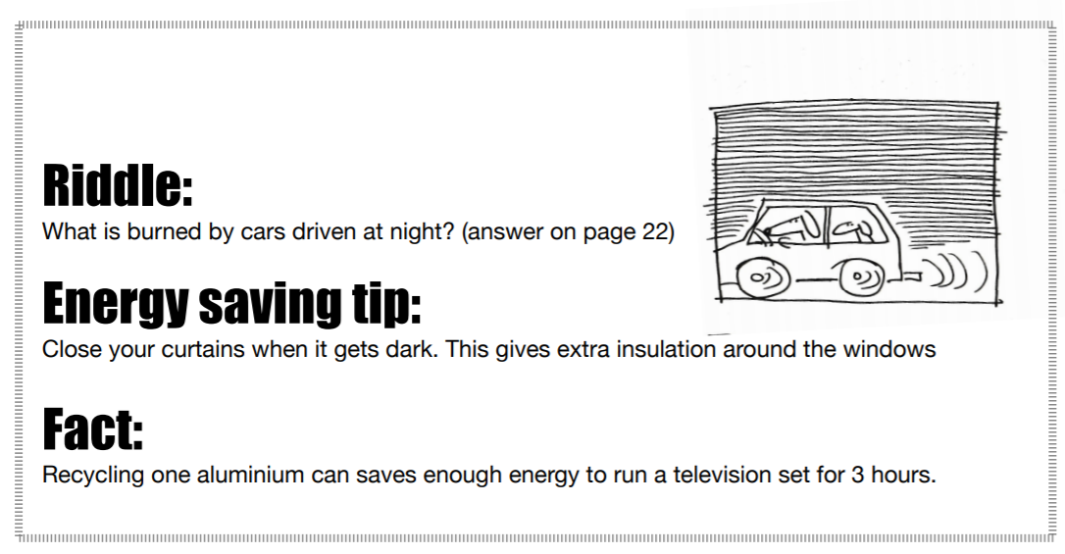

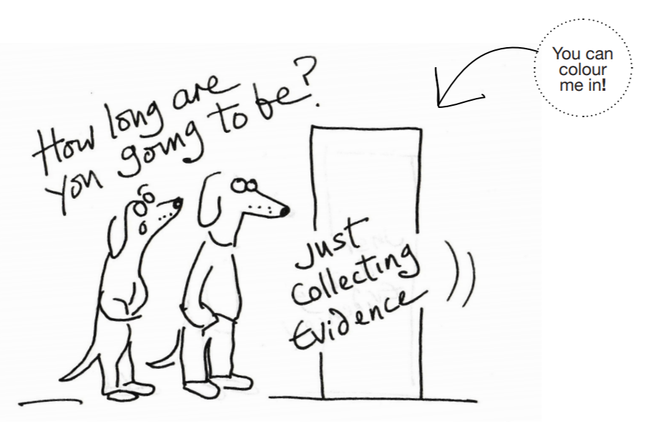
How long do you spend in the shower excluding how long you take to dry yourself? (Do not take any clocks or watches into the shower.) 3 minutes is the recommended time to spend in a shower.

Or if you have a bath measure how deep the water is? Remember heating water takes a lot of energy.
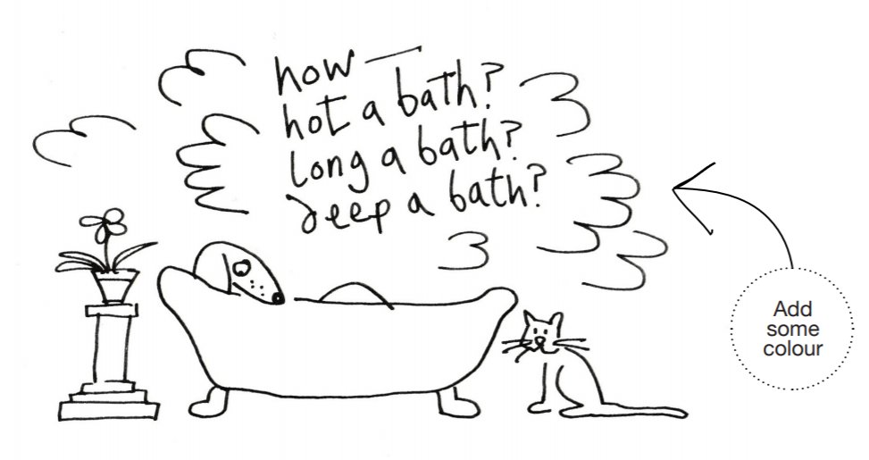

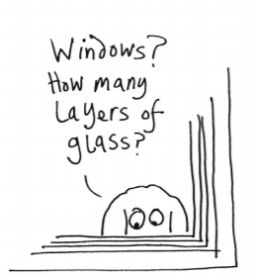
Draw a picture of the types of windows in your home. You can use a ruler. Label how many layers of glass they have and what the frames are made of. (Windows with 2 layers of glass are said to be double glazed, find out what windows with 3 layers of glass are called.) You can use an extra sheet of paper if you need to.

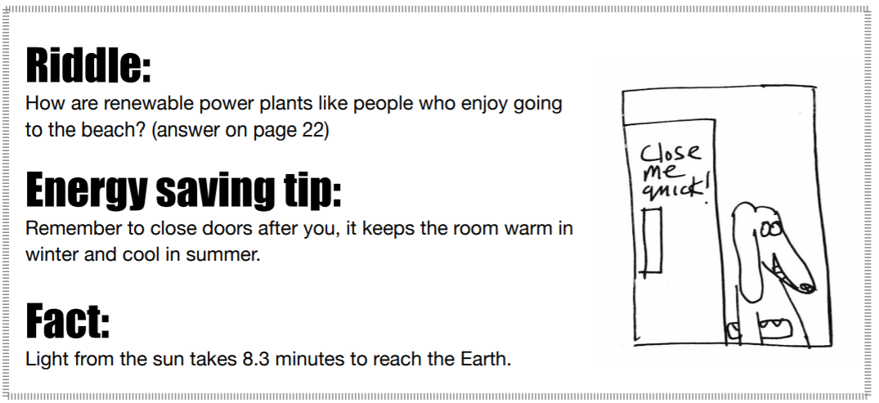
Windows with 3 layers of glass are called: ____________________________________

Are there any places in your house where it is always colder even when the heating is on? List where these are and try to work out why that is.
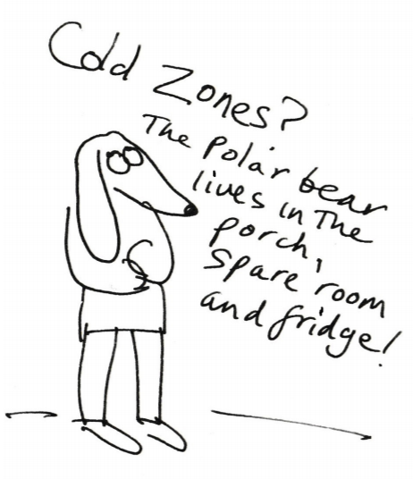

Draw a picture of the main things that make heat to keep your home warm. What type of fuel is used? You can use an extra sheet of paper if you need to.

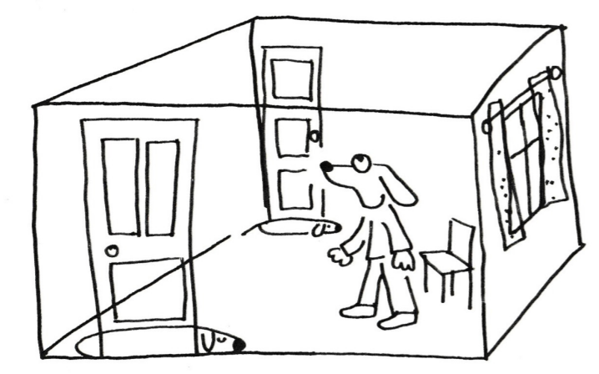

Some homes have rooms heated separately or not at all. Some have central heating where each room has radiators or underfloor heating. Investigate how the rooms below are heated in your home. Some may have more than one way that they are heated.

Tick the type of heating for each room below.
Room heated by | Living Room | Kitchen | Bedroom | Bathroom
Underfloor
Radiators
Night Storage
Electric heater
Open fire
Wood stove
No Heating
Other
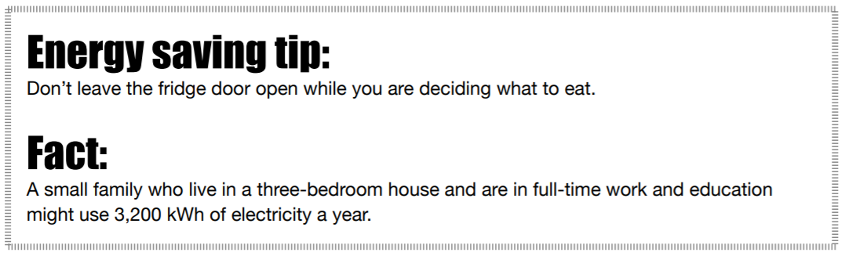

Item | Timed | Sensor
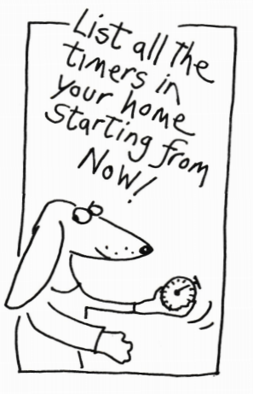
Do you use any items inside or outside your home that are either on timers or use a sensor (these can be motion or light sensors)? Please list the items below and tick whether they are timed. or on a sensor.

Light bulbs.
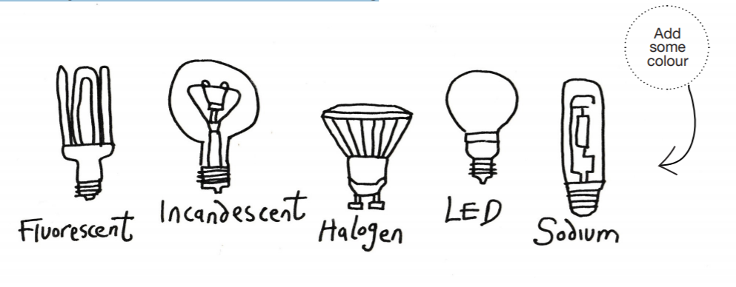
There are many different types of light bulbs and modern ones are more efficient and use less energy to give us the light we need. Watch this video that explains how the light bulb works. https://www.youtube.com/watch?v=l1Arc_REGEg

Go around your home and count the number of different types of bulbs you find:

Types of lightbulbs most efficient at the top | Number
LEDs (Light Emitting Diodes). Tip: look for the dots through the glass.

Fluorescent bulbs or tubes. E.g. Small spiral type bulbs are Compact Fluorescent Lights (CFLs) or tube strip lights.

Halogen. Tip: there is only one bulb

Incandescent. Tip: look out for the wire filament.

Sodium (mostly used in sports stadiums and streets, they have an orange glow.) Are your street lights sodium?

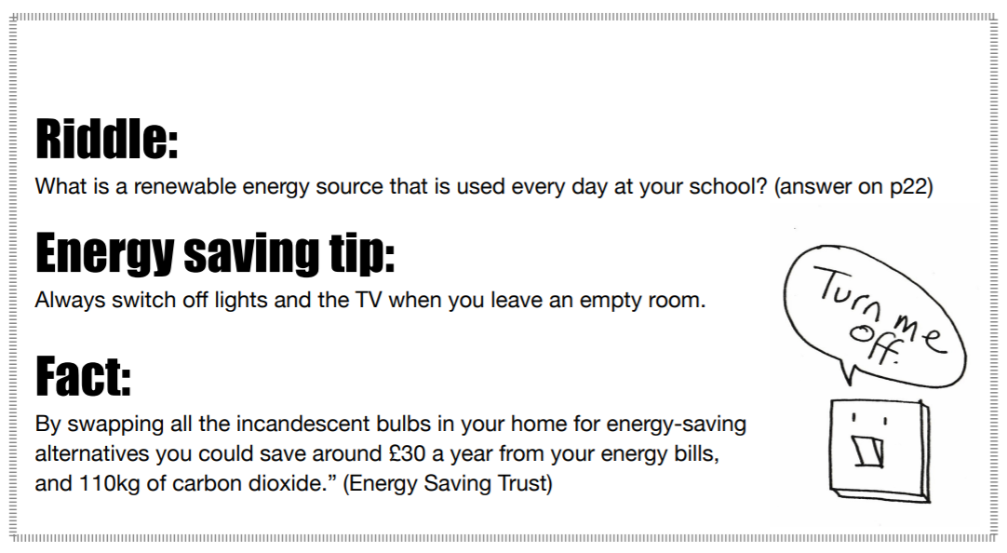

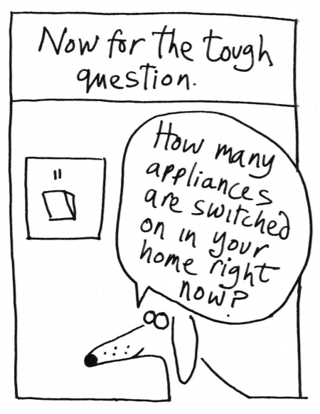
Count how many things using electricity are switched on or are left on standby in your home.
Write the number here: ___

Count how many items have been left on unnecessarily and could be switched off. (Remember that some items in your home have to be switched on all the time e.g. the deep freezer, so please check if you don’t normally switch something off)
Write the number here: ___

What could be switched off?

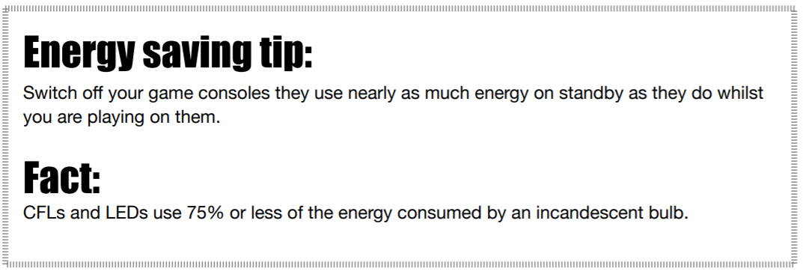
Make a poster for you (and the rest of your family) to pledge what you will do to save energy in your home. (We would love to see pictures of your posters on our website). You could photograph them and send to: info@lightfootenterprises.org

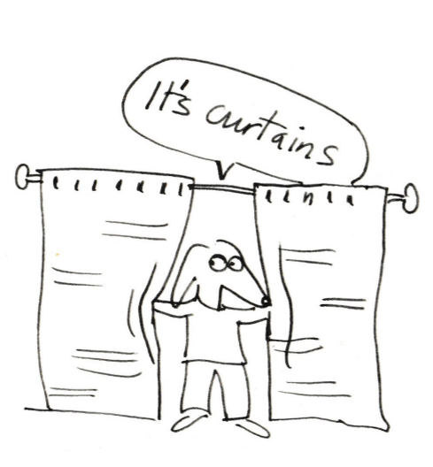
Can you think of any other ideas that would ideally save energy in your home? Please write a list:

In your list above give yourself a BIG tick if you wrote “keeping out draughts”. A draught from a window, a door, an unused chimney or even from cracks in walls and floorboards can make you feel cold even when the temperature of the room is high. Hunt them down and stop those draughts. There are plenty of internet sites that show you how you can make your own draught excluder. Happy sewing!
Design your own draught excluder below.

NOTE FOR ADULTS - Air bricks/vents help to prevent the build-up of mould as well as carbon monoxide. It can be dangerous to cover them.
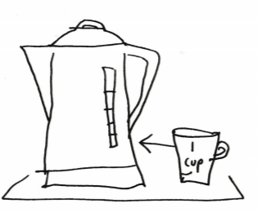
Draw pictures of the things in your home that heat water for you, and your family, to use for washing, cooking, cleaning and so on.

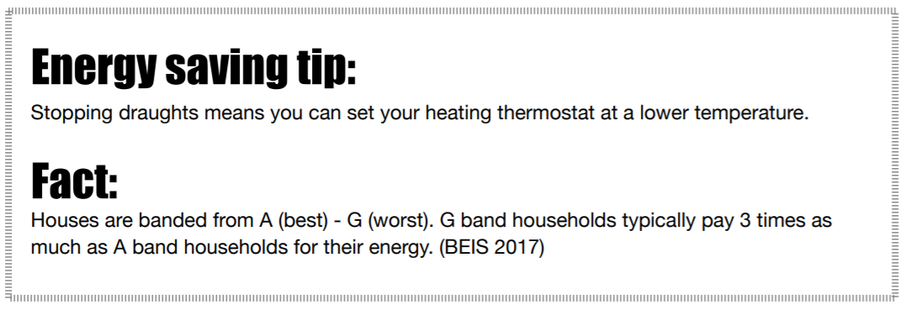
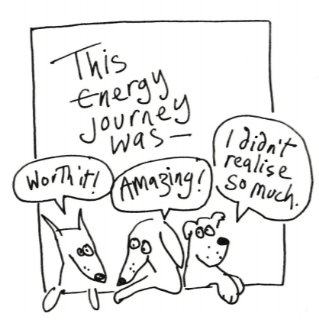

Draw a circle around the number that shows what you think about the following questions:
I think it is important to reduce the amount of energy I use:
1 | 2 | 3 | 4 | 5
Not important |  |  |  | Very important

This diary has helped me to understand about energy use in my home:
1 | 2 | 3 | 4 | 5
Not much |  |  |  | Lots

I’ve enjoyed doing this diary:
1 | 2 | 3 | 4 | 5
Not much |  |  |  | Lots

I know more about energy now since I’ve completed this diary:
1 | 2 | 3 | 4 | 5
Not much |  |  |  | Lots

Answers to the riddles:
Why did the foolish gardener plant a light bulb?
Answer - He wanted to grow a power plant.

What is burned by cars driven at night?
Answer - Midnight Oil

How are renewable power plants like people, who enjoy going to the beach?
Answer - They all like Sun, Wind and Water.

What is a renewable energy source that is used every day at your school?
Answer - Brain power!

Source: https://www.eia.gov/kids/
Lots of information, games and puzzles can be found here.

More things to find out from here https://jointhepod.org/students/primary

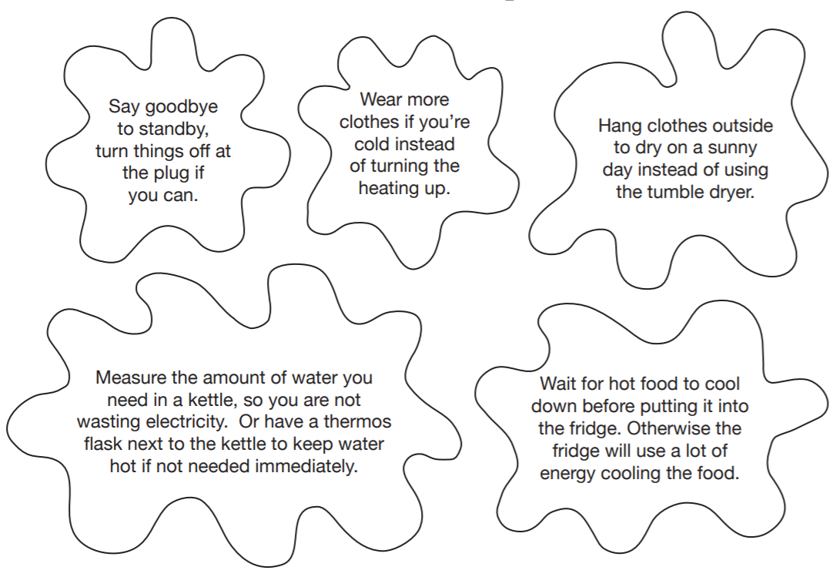
Extra useful tips!

Extra resources

There are some great free resources available on the following sites:

https://www.twinkl.co.uk/search/energy https://www.therenewableenergycentre.co.uk/educational-resources/
https://bpes.bp.com/
https://www.stem.org.uk/primary-science
https://pstt.org.uk/resources
https://www.geography.org.uk/Teaching-resources https://www.teachitprimary.co.uk/resources/y4/electricity/physical-processes/sources-of-electrical-power/30423
https://se-ed.co.uk/edu/

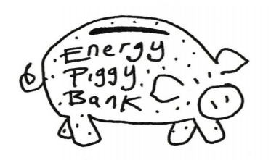

We hope you have enjoyed doing this diary and learning about energy in your home.
We would love to see your diary, E-mail: info@lightfootenterprises.org
Look at the website for tips to save energy, https://www.lightfootenterprises.org

Lightfoot- Delivering community-based, experience-driven,
ecological tools for change.

Light Foot Enterprises is a company registered in
England and Wales no. 06494228 & is a registered charity no. 1154310
Registered office: 32 The Wintles, Bishops Castle, Shropshire, SY9 5ES
© Lightfoot

This Energy Diary was originally developed by Amanda Brick, and
updated by Alison Weeks and Lorraine Waumsley, on behalf of Lightfoot Enterprises Ltd.
Illustrations © Angela Martin. Design Vic Butt
2020

